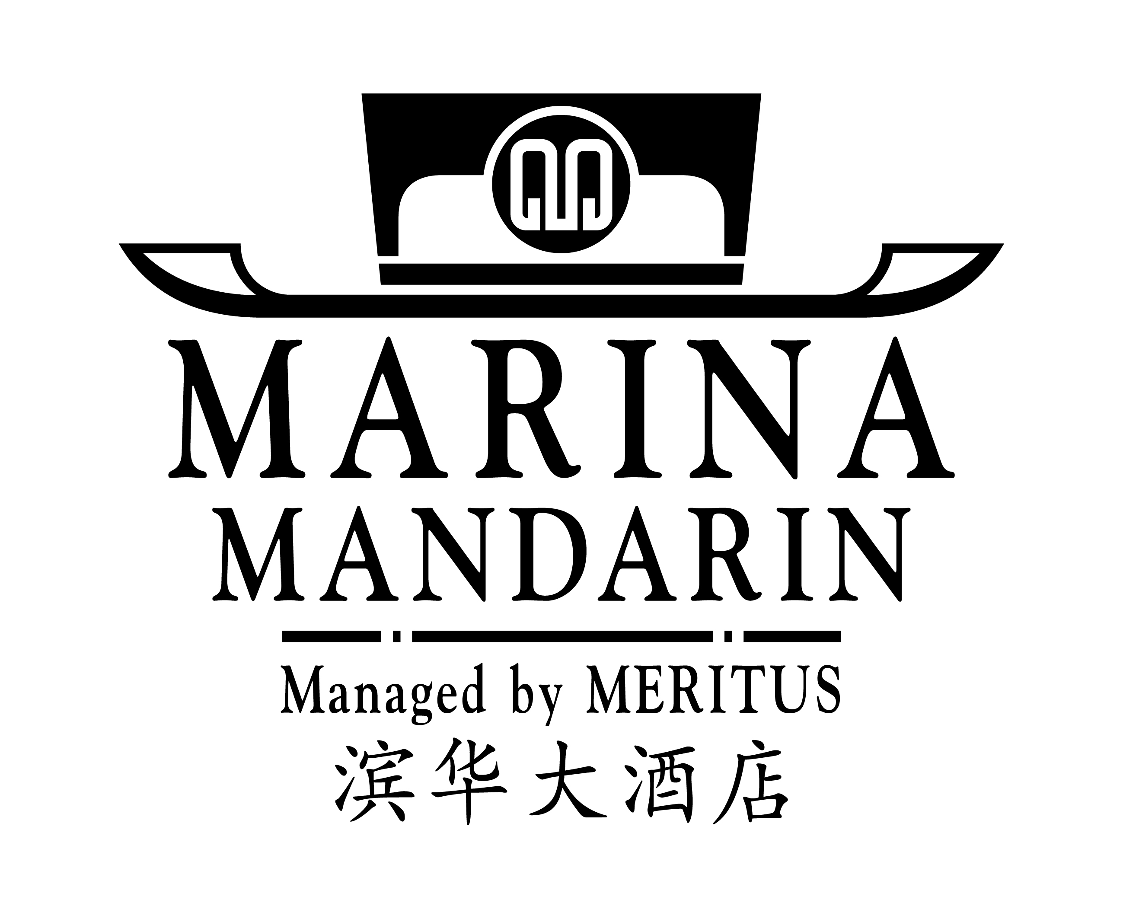

6 Raffles Boulevard, Marina Square, Singapore 039594
Telephone : (65) 6845 1000 Facsimile : (65) 6845 1199
Email : resvn.mms@meritus-hotels.com

ROOM RESERVATION FORM

BLACK HATS EVENT

16 – 19 DECEMBER 2003

To secure a confirmed reservation, please complete and redirect attached form to the Hotel by Monday, 01 December 2003.

Family/Last Name : First Name :
Salutation : (Mr / Ms / Mdm / Mrs / Dr / Prof)

Organization :

Mailing address :
City : State : Postal/Zip Code: Country :
Phone : Fax : E-mail :
Date of Arrival : Date of Departure: Number of Nights:
Flight Number/Time : Flight Number/Departure Time:
Room Category

Deluxe Room at SGD$140 +++ (Room only)

Remarks : : (if any)

Rates quoted are subject to 10% service charge, 1% government tax and 4% goods and services tax (GST) per room per night. A 1 night non-refundable deposit is required for a guaranteed reservation.

Please guarantee to my credit card: American Express Visa Mastercard Diners Others (pls specify).

Card Number: Expiry Date:
Cardholder's name: Signature of Cardholder:
Any reservation request after 01 December 2003 will be subjected to room availability.
One night room rate will be levied for no show or if reservations are cancelled less than 7 working days prior to arrival.
Check-in time is 1400hrs and Check-out time is at 1200hrs
If you are arriving in the early hours of the morning, we suggest that you reserve your room for the night before to ensure that your room will be available upon check-in.
Request for early check-in and late check-out are subject to room availability.
Room reservations without arrival flight details or non guaranteed reservation by credit card will be released at 1800hrs on date of arrival.

For Hotel Use : YOUR RESERVATION IS CONFIRMED.

Confirmation No: Reservation Associate: Date:

